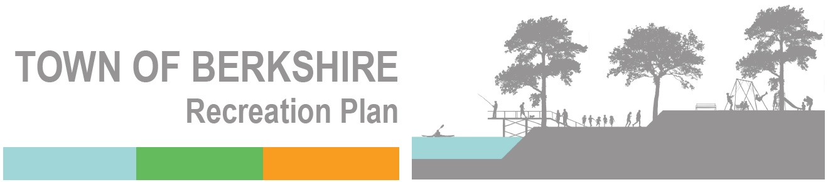
Meeting Wednesday, December 1, 2021, 9:00am
Board Report

Meeting Attendance—A. Biscontini, J. Lacey, G. Lohmann, N. Lohmann, P. Magnus, F. Williams
New Committee Members: Recently Noah Hendricks and Adrian Biscontini have joined the Recreation Committee.
Security System—George asked Noah to attend the Board’s work meeting on Tuesday, November 14, to help clarify the logistics of installing the security system for the park. Board members asked questions and came to an understanding about how best to move forward. This includes a insulated box for the equipment in the pavilion.
Electricity on the Pavilion—Skip has agreed to install additional electrical outlets for the security system.
Clearing the Bank—As of yesterday, the debris on the back on either side of the entrance has not been removed.
Clearing the Outside Edge—The Committee is exploring ways to having the area on the outside of the walkway leveled and cleared.
The Wildflower Meadow—Penny and George weed wacked, tilled, and seeded the wildflower meadow, using seeds purchased from American Meadows and funded by a donation from Eugene Hodge and Lorraine Slate, plus seeds collected by Connie Grispino, Penny, and George.
The Patch Family Fund—George has been in communication with four members of the Patch family whose father once own the land the Berkshire Creekside Park is on. They have set up a fund request asking family members to donate to the park. This fund-raising effort will run until March 31, 2022.
Floyd Hooker Foundation Grant—$20,000 has been received from the Hooker Foundation.
Mildred Faulkner Truman Foundation Grant Application—George submitted a grant application for the Truman Foundation on November 8, 2021—for $7,000.
Next BRC Meeting Date—Wednesday, January 5, 2022, 9:00am

